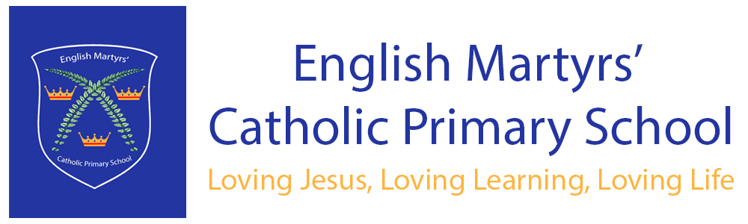

ENGLISH AS AN ADDITIONAL LANGUAGE (EAL) POLICY

Date of Approval:  Next Review Date: | October 2022  October 2024
Approved by: | Maria Elliott (Headteacher)
Changes made:

Date approved by LGC (Local Governing Committee: | October 2022

English Martyrs’ Catholic Primary School
Ethos Statement

Within the Mission Statement of the school, it makes it absolutely clear that the whole ethos of the school and all aspects of the school will reflect the practice and traditions of our Catholic faith. Such teachings direct us to believe that we are all “Children of God” and that we live by following the example of Jesus giving to us in the Gospels. We aspire to live out these Gospel Values but putting the Beatitudes into practice in all that we do.

Our school motto – ‘Loving Jesus, loving learning, loving life’; along with the Beatitudes underpin all that we do here at English Martyrs’.

The principles of striving for excellence in all that we attempt to do and taking the opportunities offered for reconciliation should be uppermost in our minds when dealing with issues particularly when this involves conflict or misunderstandings between members of the school family.

Be-attitudes

At English Martyrs’ Catholic School we follow what Jesus taught us in the Gospels., where the Be-attitudes underpin every element of our school.
As a Catholic School we have the Catholic mission at our very core.
Everyone in school is expected to actively follow and live out our mission statement:
“Loving Jesus, Loving Learning, Loving Life.”
We achieve our Mission Statement by following the Beatitudes as the foundation blocks of all we do. The Beatitudes give us the ATTITUDES that we want to BE.
We have Be-attitudes for Behaviour and Conduct (Our Core Values), Beatitudes for Learning and Beatitudes for Teaching.



Rationale

We celebrate the fact that many of our children speak more than one language and acknowledge their ability to use a variety of community languages. In our school the teaching and learning, achievements, attitudes and well-being of all children are important. We encourage all children to achieve the highest possible standards. We do this through taking account of each child’s life experiences and needs.

A number of our children have particular learning and assessment requirements, which are linked to their progress in learning English as an additional language.

Children who are learning English as an additional language have skills and knowledge about language similar to monolingual English-speaking children. Their ability to participate in the full curriculum may be in advance of their communicative skills in English.

Aims

The National Curriculum secures entitlement for all children to a number of areas of learning and gives them the opportunity to develop the knowledge, understanding, skills and attitudes that are necessary for their self-fulfilment and development as responsible citizens. We promote the principles of fairness and justice for all through the diverse education that we provide in our school.

The aim of this policy is to help ensure that we meet the full range of needs of those children who are learning English as an additional language. This is in line with the requirements of the Race Relations Act 1976 and Race Relations (Amendment) Act 2001.

The aims of this policy are to enable pupils who are learning to use English as an Additional Language to have full access to the National Curriculum, together with providing equality of opportunity, in order that each learner will fulfil their academic and educational potential.

Guidelines

At English Martyrs’ Catholic Primary School, we firmly believe that quality first teaching is paramount for EAL and all pupils and language learning is most successful, for both first and EAL speakers where:
- it is taught within the context of the mainstream curriculum
- oral language is central to all curriculum work
- the informed contribution of parents to their children’s education is seen as vital to the children’s progress.

To achieve our aims the school will:-
- facilitate the language development of pupils across the curriculum
- acknowledge the cultural and educational value of pupils’ mother tongues
- make effective use of pupils’ first language to support access to and develop conceptual development across the curriculum when possible
- reflect the linguistic and cultural diversity of the school in its resources, texts, materials and displays
- develop links between the parents of EAL pupils and the school.
- At English Martyrs’ Catholic Primary School teachers take action to help children who are learning English as an additional language by various means.

We aim to develop spoken and written English by:
- ensuring that there are effective opportunities for talking, and that talking is used to support writing;
- displaying key vocabulary;
- explaining how speaking and writing in English are structured for different purposes across a range of subjects;
- ensuring that vocabulary work covers the technical as well as the everyday meaning of key words, metaphors and idioms;
- providing a range of reading materials that highlight the different ways in which English is used;
- encouraging children to transfer their knowledge, skills and understanding of one language to another;
- building on children’s experiences of language at home and in the wider community, so that their developing uses of English and other languages support one another;
- We aim to ensure access to the curriculum and to assessment by:
- using accessible texts and materials that suit children’s ages and levels of learning;
- providing support through ICT, video or audio materials, dictionaries and translators, readers and amanuenses;
- using the home or first language where appropriate;
- setting targets in literacy for targeted children

Curriculum Access

Learning an additional language is a long-term process. While social fluency may be acquired within two years, it may take EAL pupils from 5 to 7 years to gain the skills and understanding to participate fully in an educational system, in-line with mother tongue speakers of English.

All children at English Martyrs’ Catholic Primary School follow the curricular requirements of the Foundation Stage and the National Curriculum. Children with English as an additional language do not produce separate work, unless within a focused target intervention group.

We do withdraw children from lessons to receive EAL support in order to support those children who are targeted and in need of additional small group work, in addition to those children who are new to English.

Teaching assistants are timetabled to support individual children or small groups of children. In the Foundation Stage we plan opportunities for children to develop their English, and we provide support to help them take part in activities.

The Foundation Stage helps children learning English as an additional language by:

- providing several role play areas whereby the children can mimic and copy their peers and listen to the English language through play;
- building on children’s experiences of language at home and in the wider community, so that their developing uses of English and of other languages support one another;
- providing a range of opportunities for children to engage in speaking and listening activities in English with peers and adults;
- providing bilingual support to extend vocabulary;
- providing opportunities for children to hear their home languages as well as English.

Assessment

An annual audit of need is completed by the co-ordinator responsible for the teaching of children who speak English as an Additional Language.

The teacher responsible for EAL and the teaching assistant who supports this work support teachers in identifying the language needs of bilingual pupils. The wide distribution of EAL pupils across the school necessitates withdrawal of individual pupils or small groups for specific teaching activities.

In the Foundation Stage we assess the children using BPVS. This gives us a level of their vocabulary and we can then measure their achievement. Small groups of children who speak English as an additional language are timetabled to work with support staff who are trained to support this work.

Speaking, listening, reading and writing targets are set and again progress in measured half termly by the EAL coordinator.

Attainment and progress is recorded at least half termly in line with agreed school procedures for children who speak English as an additional language.

Targets are reviewed and children in need of additional support highlighted in accordance with school policy.

Conclusion

All teaching staff are aware that bilingual children may have a competence in their first language, which equals or surpasses their competence in English.

They acknowledge that an individual child’s mature, and high-level understanding of his or her first language is of great benefit in his or her learning of English as an Additional Language.

All teachers accept that a child’s first language is a powerful tool in developing their conceptual learning through the medium of English.

Children who are new international arrivals are encouraged to use their first language as a means of communication and to access the curriculum whenever this is possible.

